React Vite / Jest Testing & Performance Review Practice

Note: Before you start work today, please take a few minutes to think about your priorities for the week and put them in your 1:1 doc (Remember it is OK if things change, this is not set in stone!)

Working with your Trio/Buddy:
- Discuss: Which GIF makes you laugh? Why?
- Reflection: In today’s day doc image, what are the test declarations actually testing? What is a snapshot, how many were there?? What is a test suite, how many tests were in it?
- Explore: Analyze the performance review example in the following exercise

GitHub Issues Activity: Last week you created GitHub issues for a project and requested to work on a peer’s issue. You should still be working on creating a pull request in response to one of your cohort-mates past project issues. You may need to follow up with the issue owner if you haven’t been confirmed as assigned to work on the issue by now. Take today to plan out your daily work for the PR if you haven’t already started making progress, in order to time manage your work alongside your weekly project and other deliverables. The purpose of this exercise is to get you thinking about project collaboration, which you will do when working on a production team in your first role. Be prepared to also share your PR in response to a peer’s issue during this week’s project share.

Cohort Activity: Effective Performance Reviews: Giving and Receiving Actionable Feedback

Weekly Project:
This week you will be building a Game / Quiz App using the api. Using the Open Trivia API.

Objectives
- Understand using callback functions to pass data from a child to a parent or using useRef() to control input forms
- Become more comfortable with forms in React
- Using GET Request, ask for data from your db!
- Parse and display JSON data
- Create instances for components in React and use props and state to manage data. This assignment will check for proficiency in NodeJS and ExpressJS and how to connect your backend with the frontend.
- Comprehension of the following frameworks:
  - Backend: ExpressJS, NodeJS
  - Frontend: React, Vite
  - Libraries/Tools: Postman, Fetch, Jest
  - Apply Testing with Jest

Overview
In this project, you will build a minimal Game / Quiz connecting your Backend and your frontend.
- Pre-Win: The game's existing code already grabs the user information and shows the user the questions that exist in the fakedata.js file.
- Win # 1: Grab the real information with the API and show it correctly in the Frontend.
- Win #2: It should grab how many questions the user has an answer to and how many right/wrong questions.
- Win #3: It should show the user a message in case they win/lose the game.

Testing with Jest
Jest is a library for testing JavaScript code. It's an open-source project maintained by Facebook, and it's especially well suited for React code testing, although not limited to that: it can test any JavaScript code. (Text from flaviocopes.com)

It is built to give clear terminal output about why your test failed, and will even tell you what parts of your code still need to be tested (aka it gives you test coverage data). You can easily write snapshot tests that will alert you to how your new code has caused your web page to change, preventing unintended results as you work.

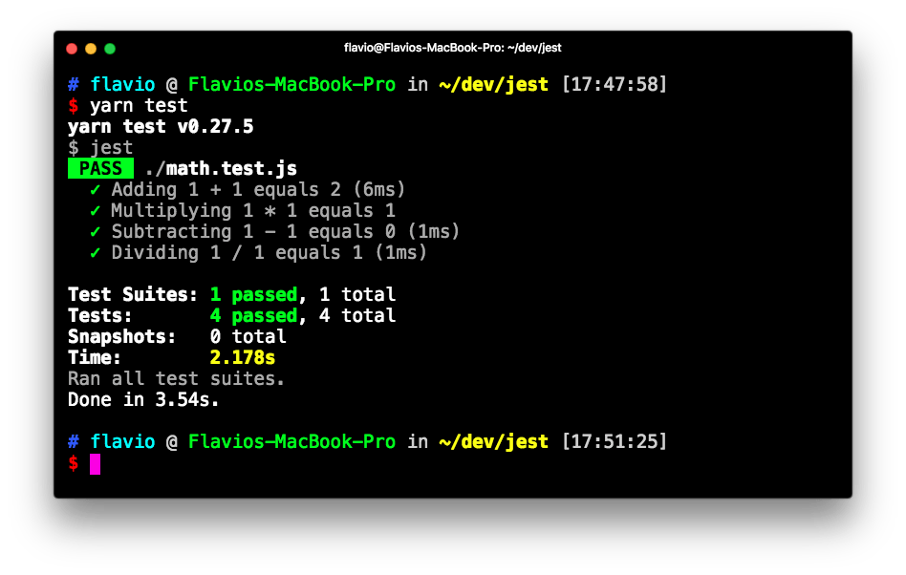
(Image from flaviocopes.com)

Function goal to add two names together first_name + “ “ + last_name

assert(Jane, Smith => “Jane Smith) true
assert(Jane, Smith => “JaneSmith”) false

Function that takes out all non letter characters

assert(“Jan29347293847e” => “Jane”) True
assert(“Jan29347293847e” => “Jan29347293847e”) False => If this returns false then I have passed my test

Spend some time with this Techtonica jest lesson to get an understanding of how tests are written and how to create specific test assertions. If testing feels abstract still, revisit the curriculum’s testing mindset topic outline.

Related (Optional) Jest Testing Resources
- 🎦Test with Jest
- 🎦Test with Jest Pair Programming
- 🌐Jest documentation
- 🌐Rithm School “Testing with Jest” course
- 🎦Testing with Vite

At the end of the day:

End-of-day questions:

SQL
- Update statement

React
- How do you start a project using Express and React?
- What does express manage in a project with React?

CSS
- CSS counters

